** **

**Circle Tipping – Admin Setup and Rules**

**v1.05 Jan 2025**

***As a venue administrator for Footy Tipping, please review this document in full to understand the setup options. Please also provide any feedback or improvements we can make within the Footy Tipping module, within this document or on our Knowledge Base.***

**Author: Rod Stafford Email:** [***rod@circlesolutions.com.au***](mailto:rod@circlesolutions.com.au)

**Contents**

1. **Tournaments**
2. **Competition Setup**
   1. **Upgrade CircleScan**
   2. **Auth-0**
   3. **Circle Tipping Central Database**
   4. **Circle Admin - Configuration**
3. **Managing Registration / Payment**
4. **Field Definitions / Rules**
5. **Knowledge Base**
6. **Reporting**
   1. **Registrations**
   2. **Patron Tips**
   3. **Process Round**
   4. **Leaderboard**

# Tournaments

Circle has 2 available tournaments:

1. NRL (trial commenced 2023 with 2 venues, 2024 ~ 20 venues ran successfully)
2. AFL (available from 2024 with 1 venue)

# Competition Setup

A venue / group needs the below setup to be followed to enable Footy Tipping:

Upgradeto the latest CircleScan version to enable any changes/bug fixes (done by Circle Support)

*Our support team will upgrade your venue/s in advance of the season. Please support by allowing for as early an upgrade as possible.*

Venue Groups will be upgraded together, noting sometimes the whole group is on Circle Tipping, sometimes only main venue, or only one venue in group will be signed up for Footy Tipping

Auth-0 (done by Circle)

*New Circle Tipping venues require authentication setup to link to the Circle Tipping Database. If your venue ran a competition the previous season then this is not required.*

Circle Tipping Central Database (done by Circle)

*This is a cloud based central database that holds the tipping competition data. This includes tournaments, venue/group setup, schedule, match results via NRL or AFL Results API*

***For venues in a group***, where more than one venue is signed up for Circle Tipping, we need to configure the competition based on whether it is a Group competition (ie multiple venues with one leaderboard/winner etc), or single venues running their own competition (leaderboard/winner per venue).

## Circle Admin - Configuration

Below is the default setup in Circle Admin. Venue Footy Tipping Admin can change this as desired to suit the competition.

Sample home screen with Footy Tipping Button

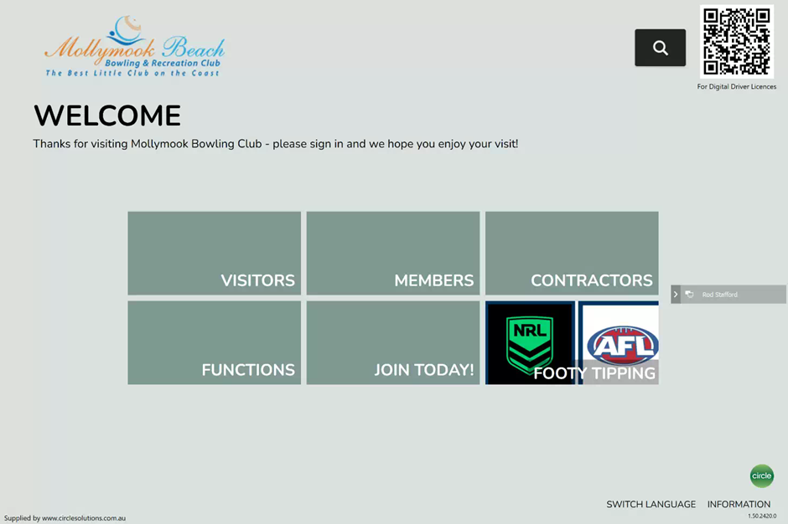

**Register and Place Tips**

-Register by swiping member card or entering member number (if enabled in admin)

-Place tips and submit.

See video below.



-Venue Admin can then review Registrations in Circle Admin

-Review Comp Rules in Footy Tipping menu

-Review Reports

See video below.



Sample tipping screen, with arrow on right for next round (if enabled via ***Display Current Round*** setting).

Submit Tips button is enabled once all games have been tipped.

Sample docket print of tips below. Noting multiple rounds many print if tipped.

Ensure venue has a printer setup on any active footy tipping terminals.

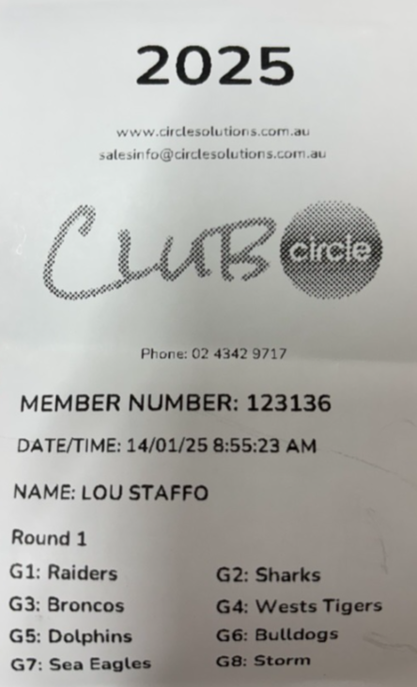

# Managing Registration / Payment

Any member can register on the terminals for Circle Footy Tipping. Some venues will charge members in order to create a prize pool (eg 1st,2nd 3rd prize money). Some examples are below for how to manage this within your venue.

*Note: If a member registers but doesn’t pay you can always remove them from the competition in the back end.*

Example club process

* Ensure marketing material aligns with venue configuration rules
* Refer to field definitions/rules for *Max Number of Days for Late Registrations* as you can lock down when season starts or shortly afterwards using this field
  + 
* Leave registrations open to every member for round 1
* At the completion of round 1, log into Circle Admin and see who has registered and compare it to the sign-up sheet (per marketing material process)
* Manage payments outside of Footy Tipping in a register or other system
* If members have registered but not paid, then
  + Ask for payment, and receive
  + If not paid, [contact Circle](mailto:%20rod@circlesolutions.com.au) and we can remove from the registration list in the back-end
  + If they are removed and then do pay, they can self-register again, noting they will have to re-place any tips
  + Note: Circle has pending development for Season 2025 for venues to be able to remove a registration within Circle Admin

# Field Definitions / Rules

|  |  |  |  |
| --- | --- | --- | --- |
| **Type** | **Field** | **Default** | **Explanation** |
| Feature | Enable Footy Tipping | Enabled | This drives the initial connection to the backend Footy Tipping Databases |
| Feature | Name | Footy Tipping | This is the name that will appear on the main screen |
| Config | Display Current Round | Disabled | Ticking this allows a member to only place tips for the current round.  Unticking allows to tip matches for future rounds.  This setting drives whether you want to force members to enter the venue each week to place their tips or not. |
| Config | Issue Points for Winning Round | 1 | This setting drives the number of **bonus points** for selecting a perfect round eg if set to 1 and selected all 8 correct games, then member would get 9 points (8+1) |
| Config | Close Round (mins) | 2 | This is the number of minutes before the scheduled kick off time where tips are locked down. Eg If set to 2 minutes and kick off is 8pm, then the match tipping would be closed off at 7:58pm. |
| Config | Issue Points for Each Correct Tip | 1 | This setting drives the number of points accrued for a correct tip. Most venues will set up 1 point per tip for simplicity, however, some venues issue more points per correct tip and then assign those points to the member in the membership or other system where the points can be used. |
| Config | Issue Points for Draw | 1 | This setting drives the number of points accrued if the match is a draw. There is no option to select a draw. |
| Config | Issue Points for Missed Tips | 1 | This setting drives the number of points accrued if tips were missed. Note this field works in combination with the *Max Number of Points for Missed Tips* field |
| Config | Max Number of Days for Late Registrations | 14 | This setting drives the number of days after the 1st match of the season that late registration will be accepted. Eg if set to 14 days and season commences 3rd March, then late registrations will be allowed until 17th March. |
| Config | Max Number of Points for Missed Tips | 8 | **SYSTEM RULE:** When a member does not put their tips in, ‘Away’ Teams will automatically be selected.  This setting can be used to cap the number of round points for a member that did not submit their tips. Eg 7 / 8 away teams may win, but if venue sets max # of points for missed tips to 4 points then member would get 4 points, instead of 7.  You could set to a high number like 20 if you wanted the member to simply get the away teams and whatever points would apply as if they selected them manually.  If set to 8, then that would ensure a member didn’t get access to any bonus points for a perfect round, but otherwise wouldn’t get punished if away teams win.  This setting is only applicable where member has missed the whole round. |
| Config | Tile image | Attached | Combined NRL/AFL Logo to appear on Main Screen. Contact [rod@circlesolutions.com.au](mailto:rod@circlesolutions.com.au) for any logo issues or if logo is required |
| Config | Show Footy Tipping on Main Screen | Enabled | This drives where the Footy Tipping button will display on your terminals. If enabled it will be on front screen, if disabled then it will appear under Members button, and not on front screen.  Some venues may not want the button on every terminal, they may have stand-alone tipping kiosks/terminals, or place one that does not cause issues with getting members and patrons through the door quickly. To configure this you must use the ***Venue Settings > Terminals*** menu and turn Footy Tipping off at a terminal level. See screen shot on next page |
| Config | Allow Manual Member Number Entry | Disabled | When ticked this allows a manual entry of the member number, rather than a physical swipe of the member’s card (when unticked). This could be utilised to put tips on when the member is not in the venue, and may be set in combination with the *Display Current Round* setting.  To enable there may need to be extra setup to ensure integration works depending on your membership system. |
| Config | Allow Tipping without Member Number Validation (NEW-2025) | Disabled | When ticked this allows a pre-registered member to place tips without confirming their status via the membership system API.  This would allow members to place tips even if the membership system API is down (eg eBet, Aristocrat, IGT, Swiftpos) which could be urgent if this happens on a Thursday or Friday. |
| Config | Print Docket | Enabled | This setting drives whether the member will get a print out of their tips made so they can track who they tipped. Hint, get them to take a photo of the print out in case they lose as this will avoid members going back to the terminal to verify their tips. |
| Config | Path for Automatic Report | See -> | C:\Circle Files\Footy Tipping  To be setup during initial setup of Footy Tipping, will house the logo as well as any other scheduled reporting. |

|  |  |  |  |
| --- | --- | --- | --- |
| **Type** | **Field** | **Default** | **Explanation** |
| Back end IT | Web Service URL | See -> | [https://circletippingserviceapi.azurewebsites.net](https://circletippingserviceapi.azurewebsites.net/) |
| Back end IT | Domain | See -> | circlesolutions.au.auth0.com |
| Back end IT | Client ID | n/a | Per Aut |
| Back end IT | Secret | n/a | Per Auth0 |
| Back end IT | Audience | See -> | [https://localhost](https://localhost/) |
| Back end IT | Grant Type | See -> | client_credentials |

|  |  |  |  |
| --- | --- | --- | --- |
| Config | Terminals > Footy Tipping | Enabled | Some venues may not want the Footy Tipping button on every terminal, they may have stand-alone tipping kiosks/terminals, or place one that does not cause issues with getting members and patrons through the door quickly. To configure this you must use the ***Venue Settings > Terminals*** menu and turn Footy Tipping off at a terminal level. See screen shot on next page |

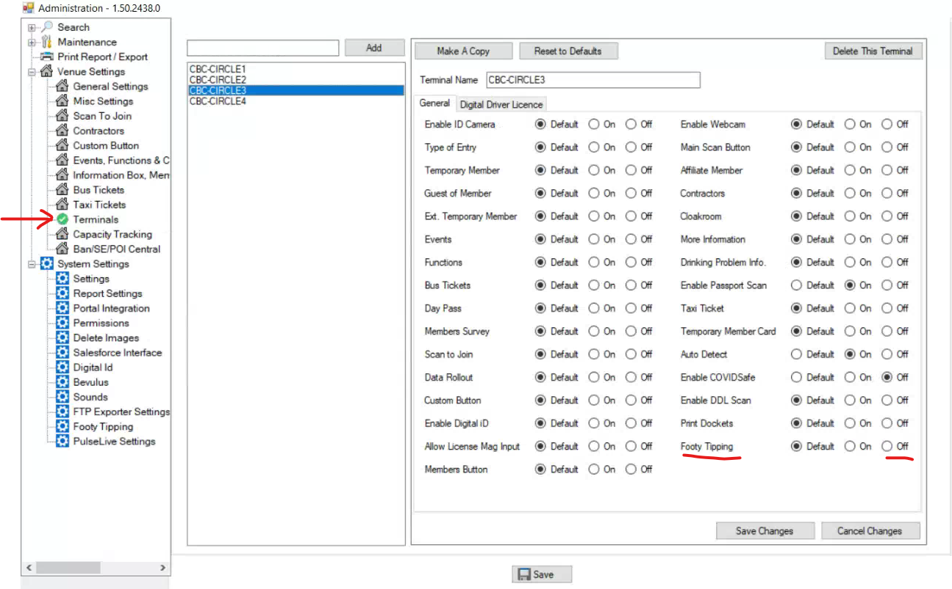

**Note: Dev Backlog Features for possible development (if enough interest)**

TIPS-84 Option to lock down tips for the whole round (ie use # of minutes but once rd1 locked on Thursday night, the whole round is locked), cannot change for a start player injury/pullout or anything

TIPS-85 Option for missing points to be allocated as 1 less than lowest score of round instead of via Max Points for Missing Tips

TIPS-90 Joker rounds - Double Points for a Perfect/Winning Round

TIPS-91 Manual points override from venue - maybe a plus or minus on aggregate points to cater for any other custom venue points rule

TIPS-65 Produce a promotion ticket for a ‘complimentary beverage’ when the member puts their tips on for the first time each week

TIPS-44 Request for Rego to be back of house or password driven (if paid comp)

TIPS-43 Integrate Footy Tipping into WYMAC Loyalty Kiosks for payment/leaderboard displays

# Knowledge Base

Further info including how to videos is available in our knowledge base

[**https://circlesolutions.com.au/knowledge-base/**](https://circlesolutions.com.au/knowledge-base/)

HINT: Use the search function by entering key words

**Videos**

DEMO PLACING TIPS - [**/footy-tipping/**](https://circlesolutions.com.au/knowledge-base/footy-tipping/)

[**footy-tipping-on-main-page/**](https://circlesolutions.com.au/knowledge-base/footy-tipping-on-main-page/)

[**circle-tipping-option-to-leave-registrations-open-on-footy-tipping/**](https://circlesolutions.com.au/knowledge-base/circle-tipping-option-to-leave-registrations-open-on-footy-tipping/)

[**circle-admin-permission-options-for-footy-tipping/**](https://circlesolutions.com.au/knowledge-base/circle-admin-permission-options-for-footy-tipping/)

# Reporting

Login to Circle Admin on terminal/back office desktop

Then go to **System Settings > Footy Tipping > Leaderboard**

From there you can go to Registrations, Patron Tips, Process Round or Display Results per below screenshots.

To print, select printer, or save, select Microsoft Print to PDF option.

## Registrations

## Patron Tips

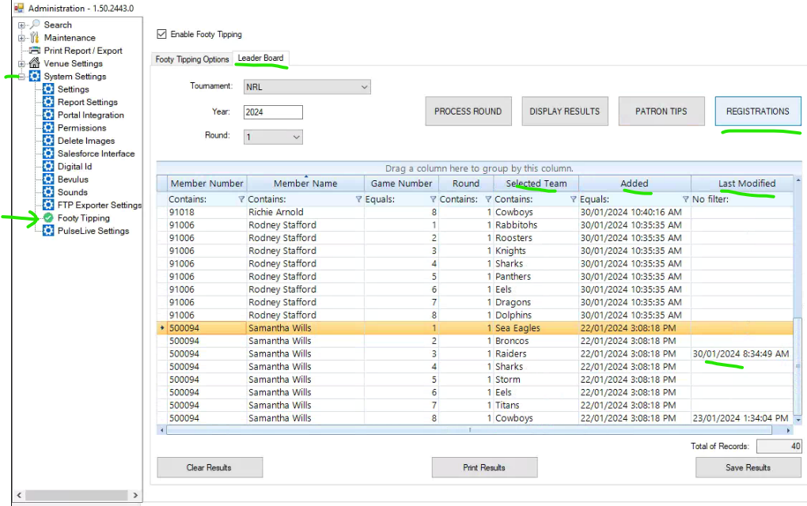

To update points after the round has finished eg system/internet was down and tips were placed manually on paper form or customer raises an issue where they think their tips were calculated wrong, or venue admin wants to run bonus points in a different way than the system rules eg no bonus points for split (short) rounds near state of origin where only 4 or 5 matches played.

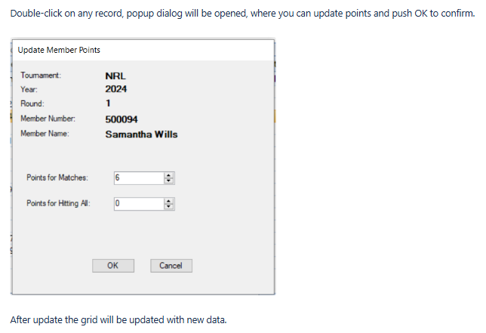

## Process Round

Each week once all matches have been completed, the NRL or AFL API automatically updates each match winner or draw. The venue will need to process the round each week for the Leaderboard to update.

Note the system will not allow a round to be processed if there are unfinished matches.

## Leaderboard – see Display Results button

This will update each week after the venue admin has processed the round per above.

To print, select printer, or save, select Microsoft Print to PDF option.

This is the PDF sample.

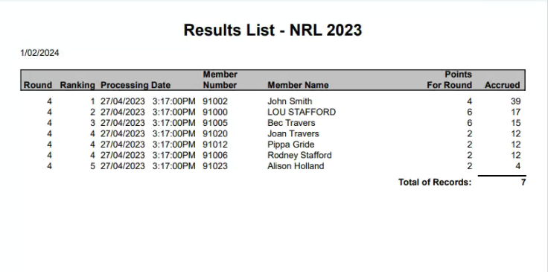

**NOTE:** For venues where membership number from swiping/API or manual entry includes a leading zero, the leading zero will be dropped for leaderboards and the database in order to avoid duplicates records. Eg member 0123 would show on leaderboards member 123. The member can enter 123 or 0123 and both will be treated as member 123.

Note: New and improved reporting is being developed as part of the Circle Dashboard rollout.

**Example of Dashboard and Dashboard reporting**

